Thermostating on demand
with Peltier thermoelectric elements
Arnošt Zukal, J. Heyrovsky Institute of Physical Chemistry, Academy of
Sciences of the Czech Republic, Prague
Karel Hořínek, E-Lab Services, spol. s r. o., Prague

When gas adsorbs onto a solid surface, temperature plays significant role in the amount of adsorbed gas. Ever – present requirement is reliably maintaining the sample at constant temperature and for a microporosity analysis for a very long time (up to 60 hours). Typically, when using cryogen liquid nitrogen (LN2) some problems may occure with changing the liquid level in the dewar consequently to its evaporation and precise measuring of the bath temperature, what is done by means of measuring the saturation pressure of the adsorbate: Liquid level is then compensated by various methods, like replacing the lost LN2 in the dewar or by means of so called isothermal jackett installed in the sample tube stem.
Maintaining stable multiple cryogenic temperatures gives us not meny possibilities: We can use high quality dewars with liquid nitrogen or argon baths, some other cryogenic coolants, which are expensive and bring problems with liquid gas supply.
Using cryostats is expensive and brings another complications as well.
Another widely used solution is circulating liquid chiller, that pumps cooling liquid to the bath compartment – circulating dewar.
Physical sorption studies required last years are adsorption of carbon dioxide, nitrogen and hydrogen (N2 and H2 on high pressures, e. g. by the ASAP2050 , CO2 in the pressure range up to 950 Torr) at temperatures below ambient, in the range of -10 °C to +80°C. Performing analysis on a sample at multiple temperatures allows the correlation between temperature and adsorbance to be seen and some new information (heat of adsorption) can be evaluated.
A perspective alternative to the expensive cryostats or liquid circulating chillers is the thermoelectric thermostat (TE) with Peltier elements, that is cheap, reliable and always-ready. The mechanical concept and cooling power can be very variable and meny on-demand constructions for a very specific need is possible.
The main feature of the TE thermostats is large variability and precision. On the other hand its limited disadvantage will always be low cooling power, that allows only introduced temperature range 0 to 80°C or when required some 20 – 30 °C below.

Figure: Molecular Sieve 13X at 0 - 20 – 40 - 60 °C

Figure: TEOS 51C at 0- 10 – 20- 30 – 40 °C

Thermoelectric coolers are solid state heat pumps based on the Peltier effect. A few main producers and plenty of types are available on the market. The typical TE module is the ceramic plate with dimensions from 6 x 6 mm to 62 x 62 mm and maximal power of one module up to 125 W. The modules can be organized into groups and controlled by common regulator. Every module has its cold and hot side and can be used to heat es well as to cool depending on the direction of the current. In an application requiring both heating and cooling, the design accents the cooling mode. The principal problem of the design is the mechanical concept so as the thermostat fits to the required space, e. g. instead of the dewar, placed on the movable lift. The interface with the process keeps down the possibility of heat insulation of the thermostated block, the design must respect specific need of the experinent or apparatus. The limitting factor of the thermostat design is then the ability to transfer heat from the hot side into the environment by forced cooling (ventilators) or by liquid cooling, that is more effective but complicates the design. Combination of all of those factors leads to the choice of an optimal TE type and configuration. The power of the modules must be optimized to achieve the maximal cooling power of the device. The upper temperature is then limited by maximum possible temperature difference between the hot and cold sides. It is usually approx. 60 °C.
General description
The introduced model IsoTherm 0-80°C was designed to be used on the ASAP2020 physisorption analyzer. It fits on the lift instead of the dewar and is connected by the standard power-supply-cord. The metal block made of Al-alloy has the hole of 20 mm diameter for the straight wall sample tubes or 32mm for sample tubes with the bulb.
The block is cooled/heated by 6 TE modules with max. power 30 W each heat sinks with forced cooling reaches the thermal resistance approx. 1,2 °C/W. This results to the temperature of the hot side ca 45°C when the target is 0°C. The minimal temperature that can be reached by this configuration is 30 °C below ambient. Max. electrical power is 110 W.
The temperature stability in the aluminium-block is established by the dual-loop PID regulator with Pt-100 thermometer. Setpoint can be easily adjusted by the keys on the front panel of the PID regulator, both setpoint and process values are visible on the simultaneous display.
Optional communication via RS-485 interface using standard Omega Process Monitoring and Logger allows adjusting of setpoints, other parameters and Ramp and Soak programming. It is also possible to optimize the PID behavior of the system. Temperature in the aluminium-block could be also monitored by the PC.

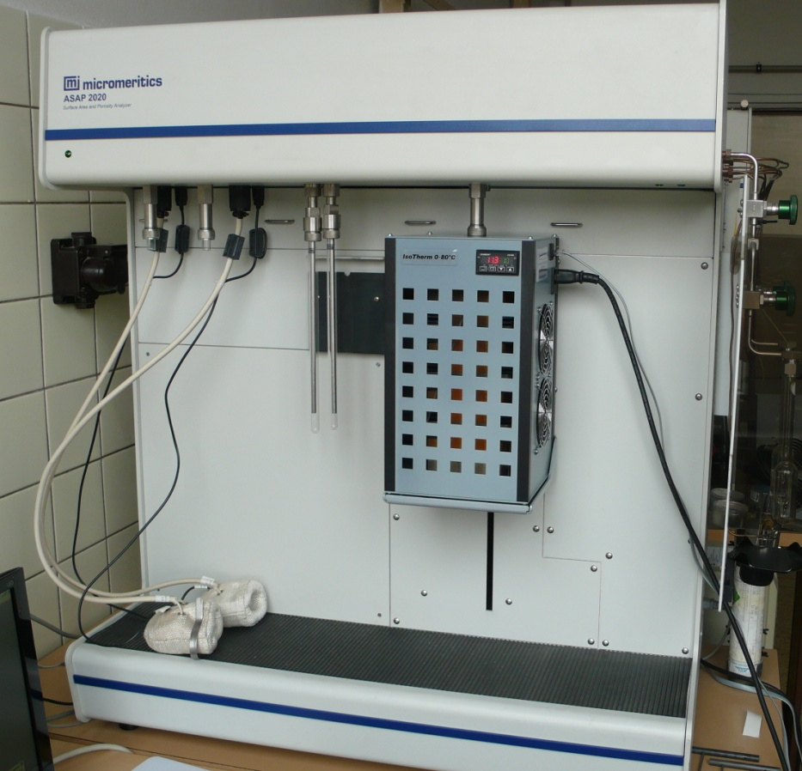
Micromeritics ASAP2020 with the Thermoelectic Elements
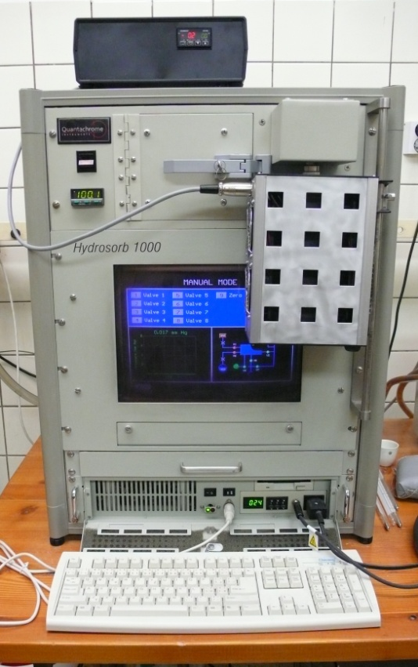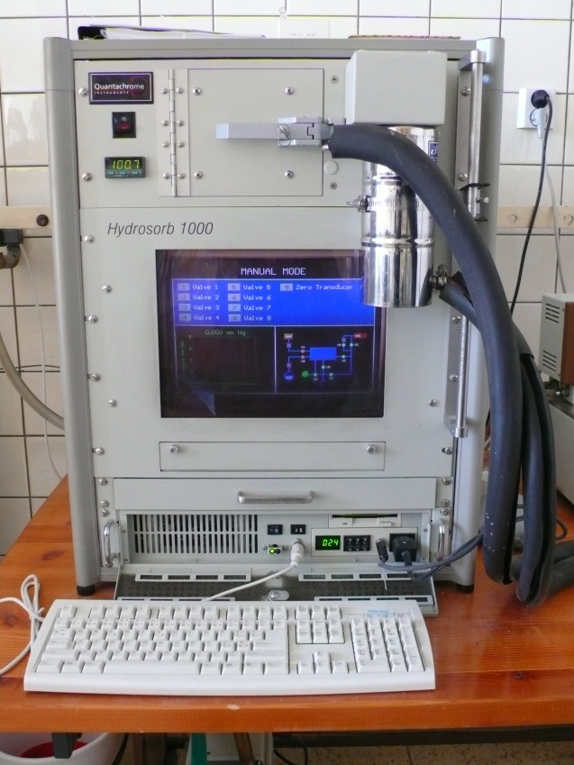
QC HydroSorb & TE Thermostat QC HydroSorb & Circulating Thermostat
Thermostat behaviour
The first performance curve demonstrates the heat load of the thermostated alu-block round 0°C. The slope of the natural heating brings the necessary cooling power of the TE system to reach temperatures 20 to 30°C below ambient. The thermostated block made of Al-alloy with 6 TE modules and optimized forced cooling reaches the temperature level of -10 °C. Heating the block above ambient is much more effective end reaching 80 °C is limited only by the maximal temperature difference between cool and hot side of the TE elements. The next graph shows the dynamics and power of the cooling to the lowest temperature. This type of device is suitable for static processes, where there is enough time to stabilize the required temperature. 60 minutes for reaching the new stabilized temperature level inside the sample tubes should be sufficient.
Snapshots of the temperature stability on 0 and 20 °C
The following ramp-test that shows stabilized temperature levels inside the sample tube and can be provided regularly to callibrate the temperatures with a precise thermometer (ASL F-100). Individual correction in the setting cann be then used to correct some unlinearity and precission of the thermostat regulator. It demonstrates also the possibility to programm temperatures.

Literature:
- A. Zukal, J. Pawlesa, J. Čejka: Isosteric adsorption heat of carbon dioxide on zeolite MCM-22 modified by alkali metal cation exchange, Adsorption, Vol. 15, 264 (2009).
- A. Zukal, A. Pulido, B. Gil, P. Nachtigall, O. Bludský, M. Rubeš, J. Čejka: Experimental and theoretical determination of adsorption heats of CO2 over alkali metal exchanged ferrierites with different Si/Al ratio, Phys. Chem. Chem. Phys, Vol. 12, 6413 (2010).
- R. Davis: Nitrogen adsorption on lithium exchanged zeolite at multiple temperatures using the ASAP2050, MicroReport, Vol. 18 No 3.
- S. Godfrey, Melcor Corporation, An introduction to thermoelectric coolers, Sept1996.

